RDS READ REPLICA
STEP 1:
CREATE READ REPLICA
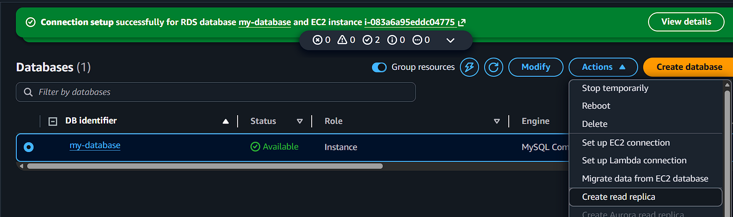
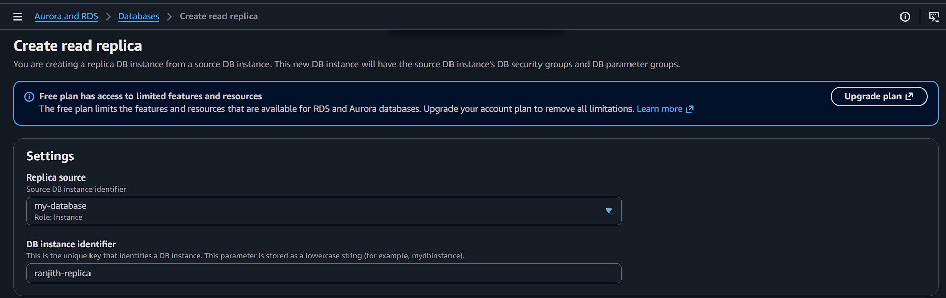

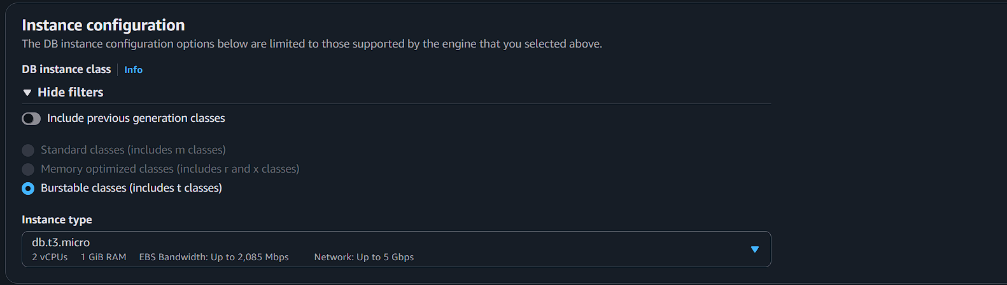

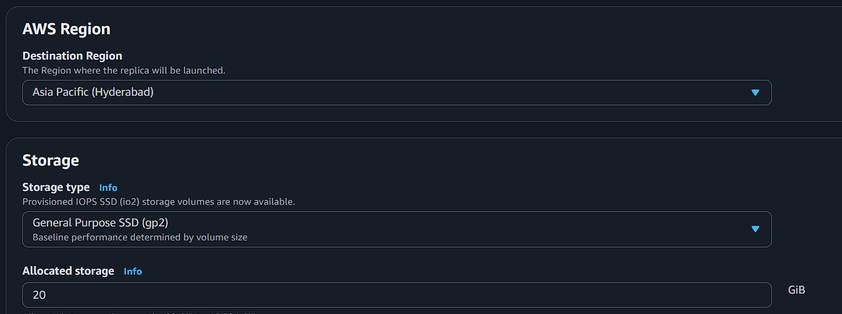

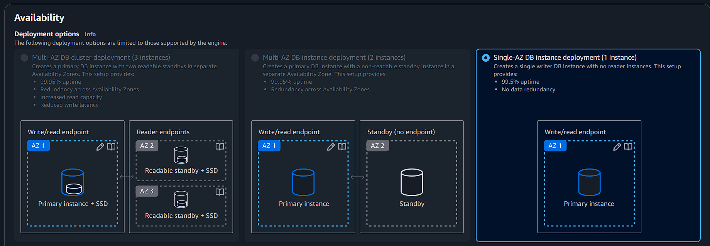
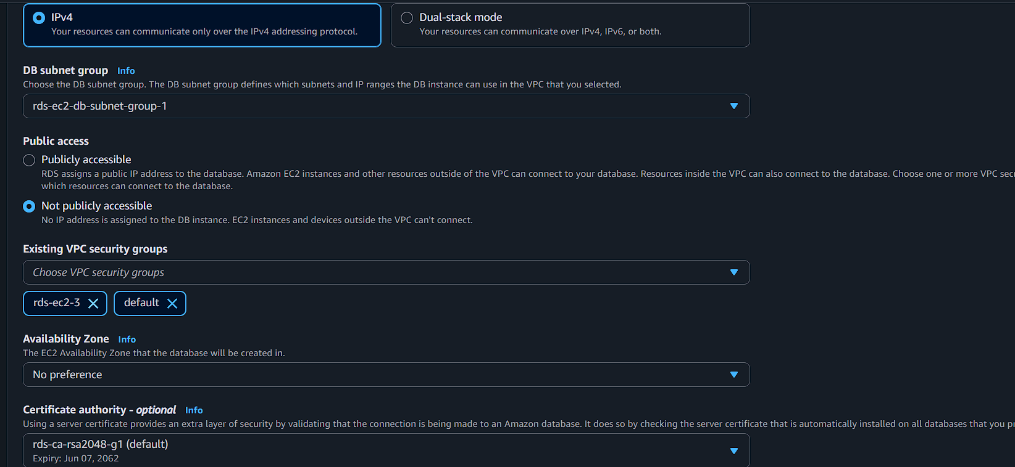

All options are default
(Hyderabad ap-south-2)
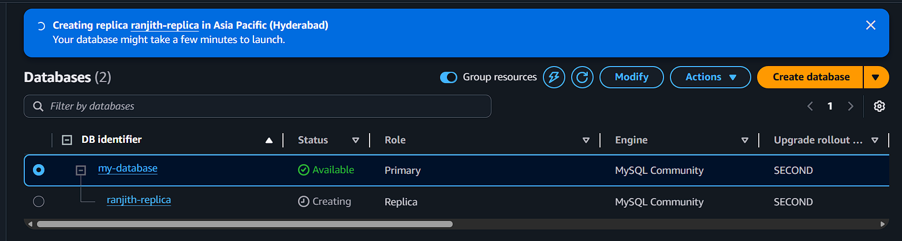
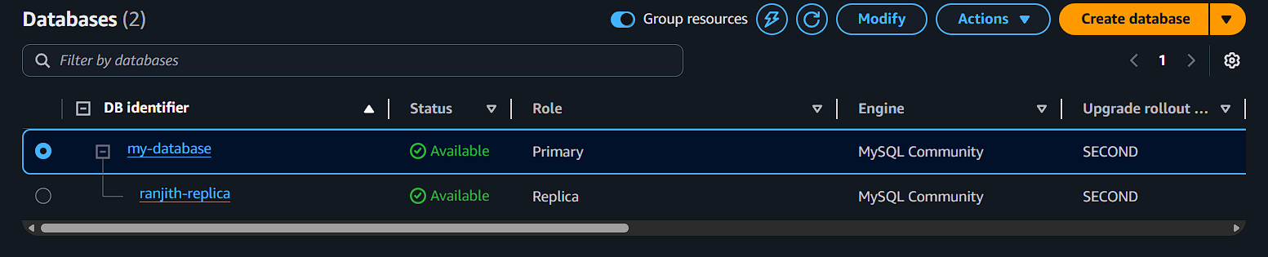
Now delete primary database
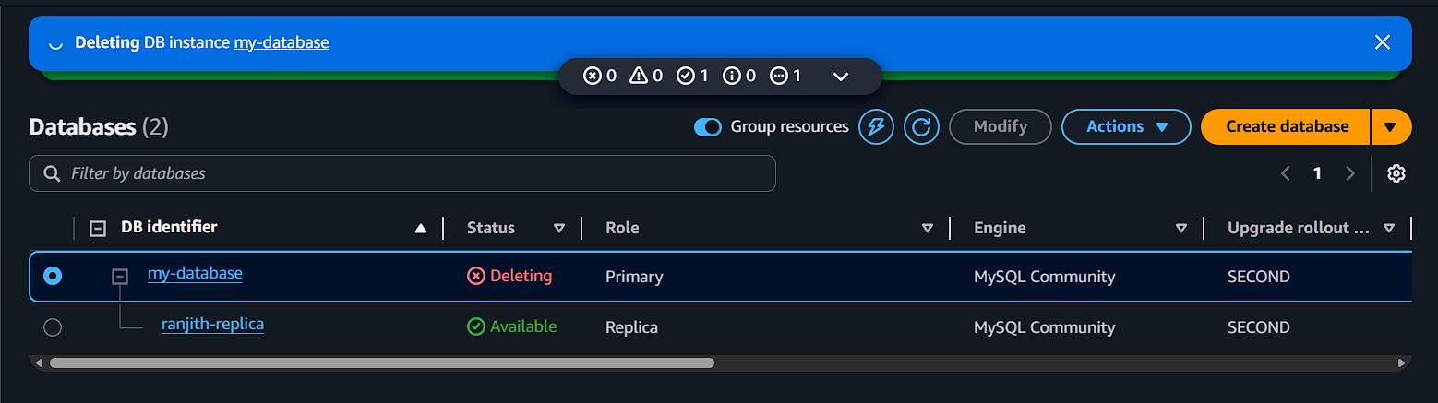
Replica can be changed in primary database
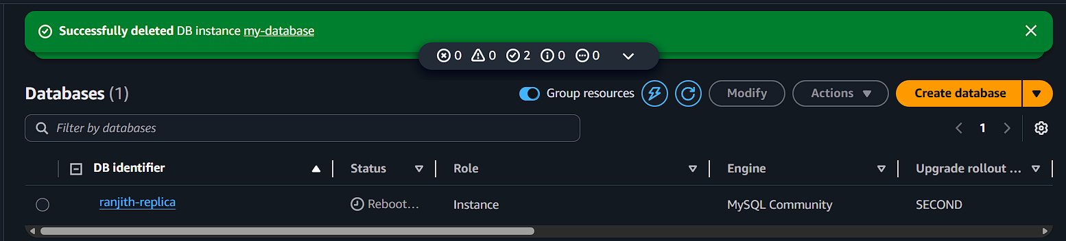
Rebooting the database
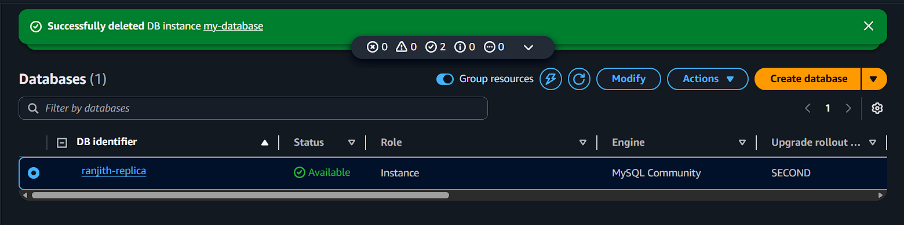
Now connect ec2 instance check
